Second Term
Lecture (1)
Q1. Look at this photo and use your imagination to tell its story.
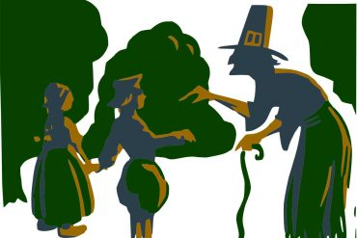

Q2. Look at this photo. What do understand from the saying. Again ,use your imagination.
